Lab Operations Software – Design Doc (MVP)

This document captures the updated design for a lab operations software MVP running on a self-hosted server. It is designed for visit-centric operations, allowing future patient accounts, culture reports, billing with discount approval, and PDF report generation.

- System Overview

  - Self-hosted lab management software.

  - Each visit is unique; patient details stored as mandatory fields in visits table.

  - Admin can define test templates (parameters, fields, price).

  - Reception creates visits; phlebotomy collects samples; lab enters results; approver validates; billing completes the cycle.
  - Supports Culture & Sensitivity (C/S) tests, discount approvals, and report PDF generation.

  - Lightweight deployment on local CPU.

- Data Model (Postgres)

referral_doctors


CREATE TABLE referral_doctors (

doctor_id SERIAL PRIMARY KEY,

name VARCHAR(255) NOT NULL,

clinic_hospital VARCHAR(255),

phone VARCHAR(20),

address TEXT,

created_at TIMESTAMP DEFAULT NOW()

);

visits


CREATE TABLE visits (

visit_id SERIAL PRIMARY KEY,

patient_id INT REFERENCES patients(patient_id), -- optional for future accounts

salutation VARCHAR(20) NOT NULL, -- Mr, Mrs, Baby, Master, etc.

name VARCHAR(255) NOT NULL,

age_years INT NOT NULL,

age_months INT, -- optional, for pediatrics

age_days INT, -- optional, for newborns

sex VARCHAR(10) NOT NULL, -- Male/Female/Other

1

phone VARCHAR(20), -- optional for contact

address TEXT, -- optional

date_of_visit DATE DEFAULT CURRENT_DATE,

referred_doctor_id INT REFERENCES referral_doctors(doctor_id),

visit_code VARCHAR(50) UNIQUE, -- optional short code for printing

created_at TIMESTAMP DEFAULT NOW(),

status VARCHAR(50) DEFAULT 'pending' -- pending, in-progress, awaiting-

approval, approved, billed, completed

);

test_templates

CREATE TABLE test_templates (

template_id SERIAL PRIMARY KEY,

name VARCHAR(255) NOT NULL,

description TEXT,

parameters JSONB NOT NULL, -- dynamic fields, reference ranges, types

base_price DECIMAL(10,2) NOT NULL,

created_at TIMESTAMP DEFAULT NOW()

);

lab_tests


CREATE TABLE lab_tests (

test_id SERIAL PRIMARY KEY,

visit_id INT NOT NULL REFERENCES visits(visit_id),

test_template_id INT NOT NULL REFERENCES test_templates(template_id),

status VARCHAR(50) DEFAULT 'pending',

price DECIMAL(10,2) NOT NULL,

results JSONB, -- normal test results

approved BOOLEAN DEFAULT FALSE,

approved_by VARCHAR(255),

approved_at TIMESTAMP

);

antibiotics (master list)


CREATE TABLE antibiotics (

id SERIAL PRIMARY KEY,

name VARCHAR(100) UNIQUE NOT NULL

);

2

culture_sensitivity_results

CREATE TABLE culture_sensitivity_results (

id SERIAL PRIMARY KEY,

visit_id INT NOT NULL REFERENCES visits(visit_id), test_id INT NOT NULL REFERENCES lab_tests(test_id), antibiotic_id INT NOT NULL REFERENCES antibiotics(id), sensitivity VARCHAR(20) CHECK (sensitivity IN

('Resistant','Sensitive','Moderate'))

);

invoices / billing


CREATE TABLE invoices (

invoice_id SERIAL PRIMARY KEY,

visit_id INT NOT NULL REFERENCES visits(visit_id), total_amount DECIMAL(10,2) NOT NULL, discount_request NUMERIC(10,2), discount_approved NUMERIC(10,2),

discount_status VARCHAR(20) CHECK (discount_status IN ('None','Requested','Approved','Rejected')) DEFAULT 'None',

approved_by INT REFERENCES users(id),

payment_mode VARCHAR(20), -- cash, card, UPI paid BOOLEAN DEFAULT FALSE, report_pdf_path TEXT,

created_at TIMESTAMP DEFAULT NOW()

);

patients (optional, future use)


CREATE TABLE patients (

patient_id SERIAL PRIMARY KEY,

salutation VARCHAR(20) NOT NULL,

name VARCHAR(255) NOT NULL,

age_years INT NOT NULL,

age_months INT,

age_days INT,

sex VARCHAR(10) NOT NULL,

phone VARCHAR(20),

address TEXT,

created_at TIMESTAMP DEFAULT NOW()

);

3

3. API Specification

Visits
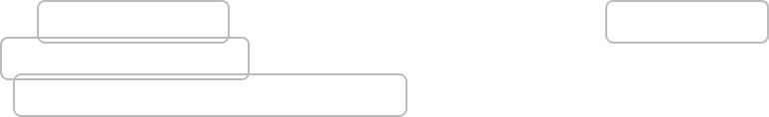

• Create Visit: POST /visits → patient details inline, optional patient_id for future accounts.

- Get Visit: GET /visits/{id}

- List Visits: GET /visits?status=pending

Test Templates
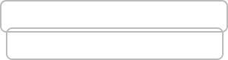

- Add Template: POST /test-templates

- List Templates: GET /test-templates

Lab Tests
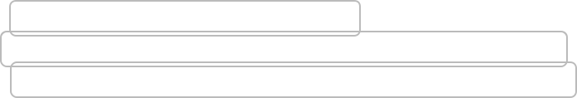

- Add Test to Visit: POST /visits/{visitId}/tests

- Update Results: PATCH /visits/{visitId}/tests/{testId}/results

- Approve Results: PATCH /visits/{visitId}/tests/{testId}/approve

Culture & Sensitivity

- Add/Update Antibiotic Result: POST /visits/{visitId}/tests/{testId}/c_s_results

- List Results: GET /visits/{visitId}/tests/{testId}/c_s_results

Billing / Invoices
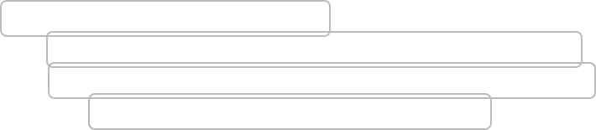

  - Generate Bill: GET /visits/{visitId}/bill

  - Request Discount: POST /invoices/{invoiceId}/discount_request

  - Approve Discount: PATCH /invoices/{invoiceId}/approve_discount (admin only)

  - Download Report PDF: GET /invoices/{invoiceId}/report

- Visit Lifecycle

  - Reception → Create visit with patient details.

  - Phlebotomy → Sample collection tracking.

  - Lab Processing → Add tests, enter normal or C/S results.

  - Approval → Supervisor/doctor approves results.

  - Billing → Bill created, discounts requested/approved, payment recorded.

  - Report Generation → PDF generated with results.

  - Completion → Visit closed.

- Frontend Behavior

• Dynamic forms for normal tests (from JSONB parameters).

4

  - C/S tests: grid with antibiotic dropdowns (Sensitive/Moderate/Resistant).

  - Discount requests visible to admin only for approval.

  - Report PDF download and print.

- Testing Strategy

  - Unit tests for services and validators.

  - Integration tests with Postgres (Testcontainers).

  - API tests using RestAssured/Postman.

  - End-to-end lifecycle tests for visit → result → approval → billing → PDF.

- Deployment Notes

  - Docker Compose: Spring Boot + Postgres.

  - Cloudflare Tunnel for fixed domain mapping.

  - Lightweight deployment: i5 CPU, 8GB RAM, 256GB SSD.

- Future Extension (Patient Accounts)

  - Visits can link to patients table ( patient_id ).

  - Migration: extract unique patients by phone/name → link visits → drop inline visit patient columns if needed.
  - APIs support patient_id but do not enforce it, keeping MVP functional without accounts.

- Acceptance Criteria

  - Visit lifecycle works end-to-end.

  - Mandatory patient details included in visits.

  - Admin-defined test templates with JSONB parameters.

  - Culture & Sensitivity test handling with structured antibiotic results.

  - Discount approval workflow enforced for admins.

  - PDF report generation for each visit with all results.

  - API coverage with tests, deployable on local server.



5

